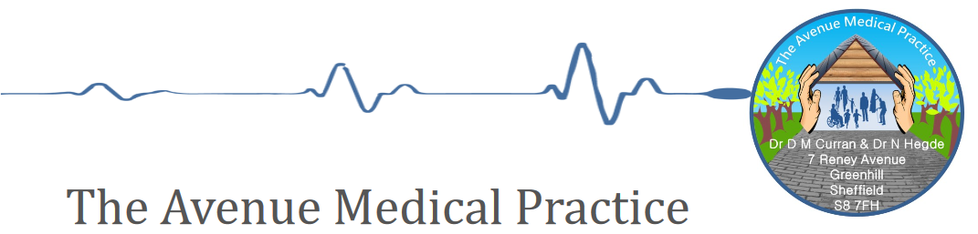
NEWSLETTER MAY 2019

Appointment System

Many of you have probably seen the recent new coverage about how GP practices are struggling.

‘The NHS is seeing the first sustained fall in GP numbers in the UK for 50 years, the BBC can reveal. An analysis by the Nuffield Trust think tank for the BBC shows the number of GPs per 100,000 people has fallen from nearly 65 in 2014 to 60 last year. There have been reports of waits of up to seven weeks for a routine appointment, while those needing urgent appointments have been forced to queue outside practices in the early morning to guarantee to be seen.’ (https://www.bbc.co.uk/news/health-48191438)

We always strive to meet patient expectation and demand, but sometimes there are not enough appointments (or GP’s) to go around. We offer appointments every day on a first-come/first-served basis, and pre-book up-to 2 weeks in advance. Our on-call system means we always ensure urgent issues are dealt with on the day. This means we don’t have patients waiting 7 weeks for appointments, but we also know it can be frustrating to get an appointment sometimes. Please help us to help you. Do you need to see a GP? The following are recent examples of people who have had unnecessary appointments:-
- Fall with large cuts/suspected Broken bones – we do not have X-ray machines and staff are not trained in the same way A&E are. Please go straight to Minor Injuries or A&E with these type of issues, as we’ll only send you there anyway
- Eye Injuries – The Emergency Eye Clinic at the Royal Hallamshire Hospital offers a comprehensive service
- Headlice/ Conjuctivitis (not in babies)/sore throats/dry eyes /Diarrhoea – please go to your local Chemist Minor Ailment scheme. If you get free prescriptions and need one- you will get it free from the Chemist and you don’t need an appointment

We have also now implemented a tougher policy on failing to attend for appointments. This is to ensure that appointments are not wasted, especially when others are needing them.

As an example on Friday 3rd May we had:-
- over 2 hours of GP/Nurse Practitioner time wasted
- 80 minutes of nursing appointments wasted.

That equates to 13 urgent appointments and 8 nurse/HCA appointments that could have been offered to other patients.

Patients failing to attend appointments will receive warning letters, but the final result will be removal from the practice for persistent offenders.

Please also remember reception are trying to help. Please do let them know if your issue is an emergency, but also consider if it could wait.

Thank you for your continued support and understanding

PPG
A Patient Participation Group (PPG), is a group of patients who attended meetings approximately once every 3 months and help us to ensure that our service meets the needs of the patients. Examples include providing advice on our appointment system changes, building changes etc..

The next one is scheduled for June. If you’d like to join we’d love to hear from you, please email SHECCG.AvenueMC@nhs.net

Annual Complaint/Compliments review

We have recently undertaken our annual complaints and compliments review. The results are below for complaints
 |  | Reason for complaint
Complaints Apr 18-Mar 19 | Total Number | Clinical Care | Appts | Attitude | Comm
Carried forward | 1 | 1
In Year | 13 | 5 | 3 | 1 | 3
Thank you for all the lovely compliments, they really are appreciated by staff

 |  | Compliment central theme
Compliments | Total | Clinical Care | Referrals/  forms | Attitude/  caring | Communication | Training | New Appt system
In year | 44 | 17 | 3 | 14 | 4 | 4 | 2

Who compliment was about
Management  Team | Admin/reception | Nurses | Nurse Practitioner | HCA | Phlebotomist | GP's | All Staff
3 | 10 | 1 | 9 | 1 | 2 | 9 | 7

BANK HOLIDAYS

Just a quick reminder that we close on Bank Holidays so PLEASE ensure you order any medications in advance around these dates.
May 27th
August 27th

A Day in the Life Of……

We understand patients sometimes can’t understand how the processes work in a practice and so this is the third in the our day in the life of descriptors. We’re covering a Practice Nurses role.

8.30am – Day starts, check over any tasks sent by reception or GP’s around patient queries, or requirements, and then start seeing patients
8.30am-12pm The Practice Nurses see patients for
- Annual reviews inc Diabetes, Asthma, COPD, BP etc..
- Baby vaccines
- Travel vaccines
- Flu and other general Vaccines
- Smears
- Wound dressings
- Injections for B12 and other medical issues
- Calling patients for routine appointments i.e Medication or chronic disease reviews
- Blood tests
- Health living advice
12- 2pm – Catch up with any onward referrals i.e Diabetes clinics, or chasing smear results before lunch

2-5.30pm- Return to appointments

